Step 1 -
Paste this code On New Terminal
VLLM_USE_TRITON_FLASH_ATTN=0 \
vllm serve Qwen/Qwen3-30B-A3B \
--served-model-name Qwen3-30B-A3B \
--api-key abc-123 \
--port 8000 \
--enable-auto-tool-choice \
--tool-call-parser hermes \
--trust-remote-code \
--gpu-memory-utilization 0.9
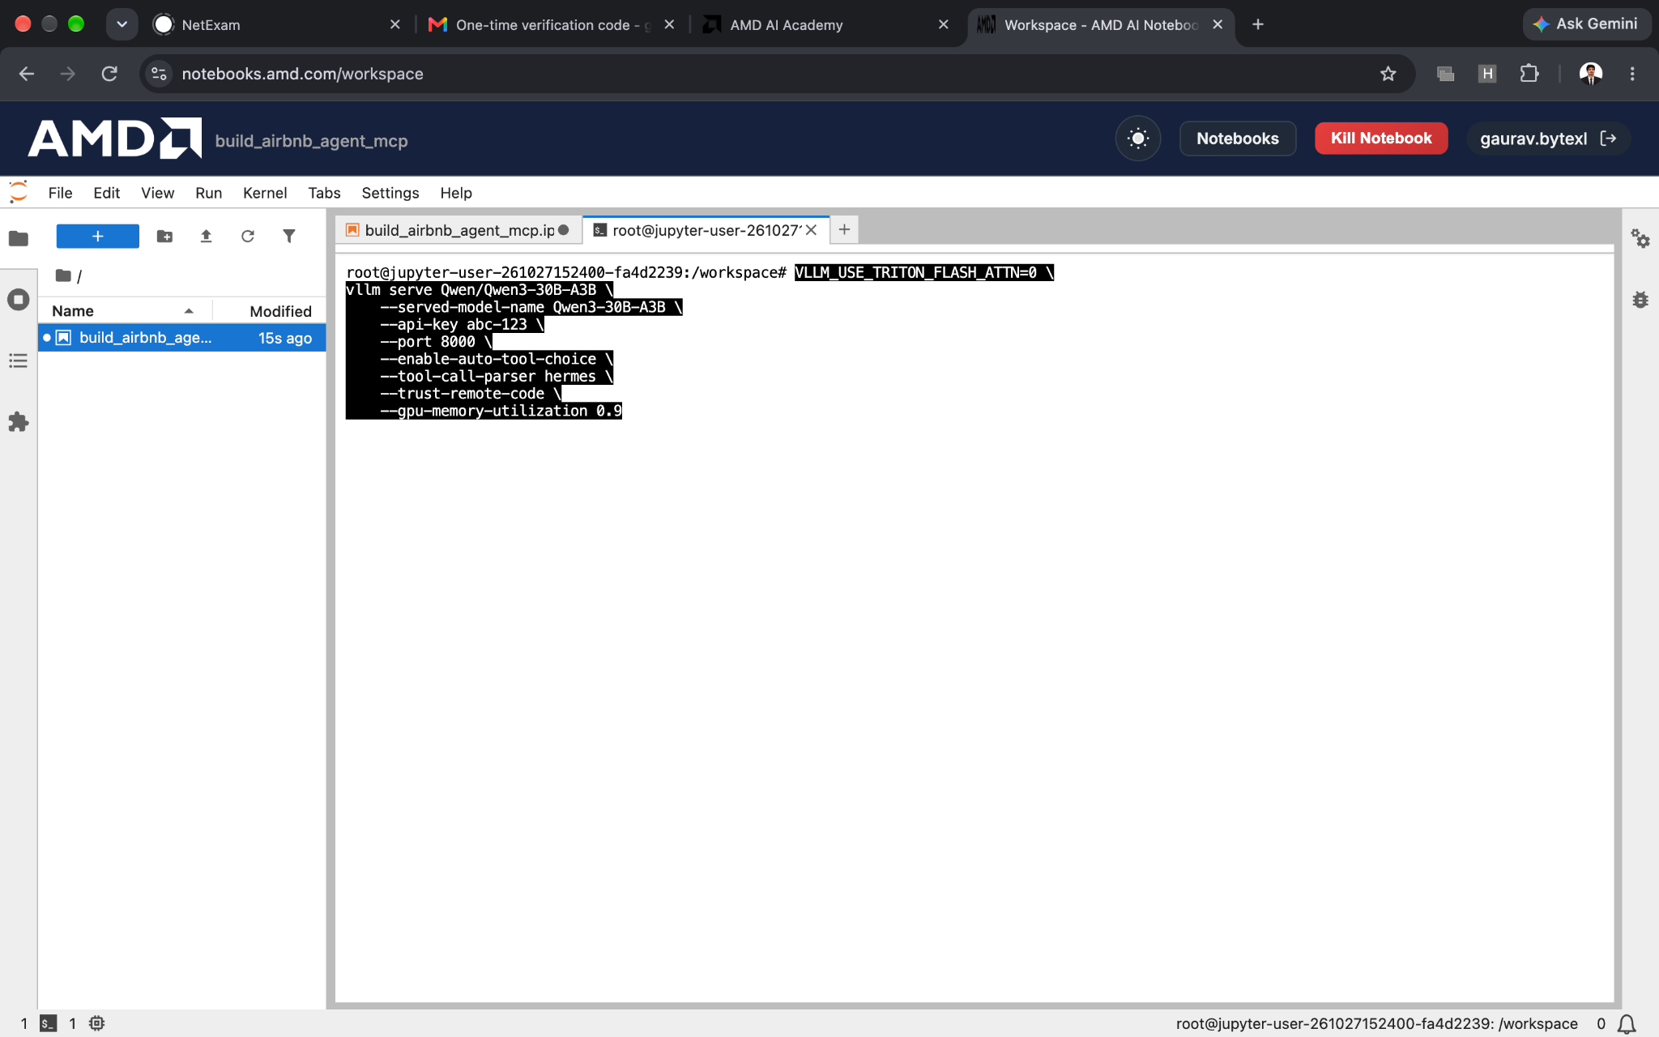
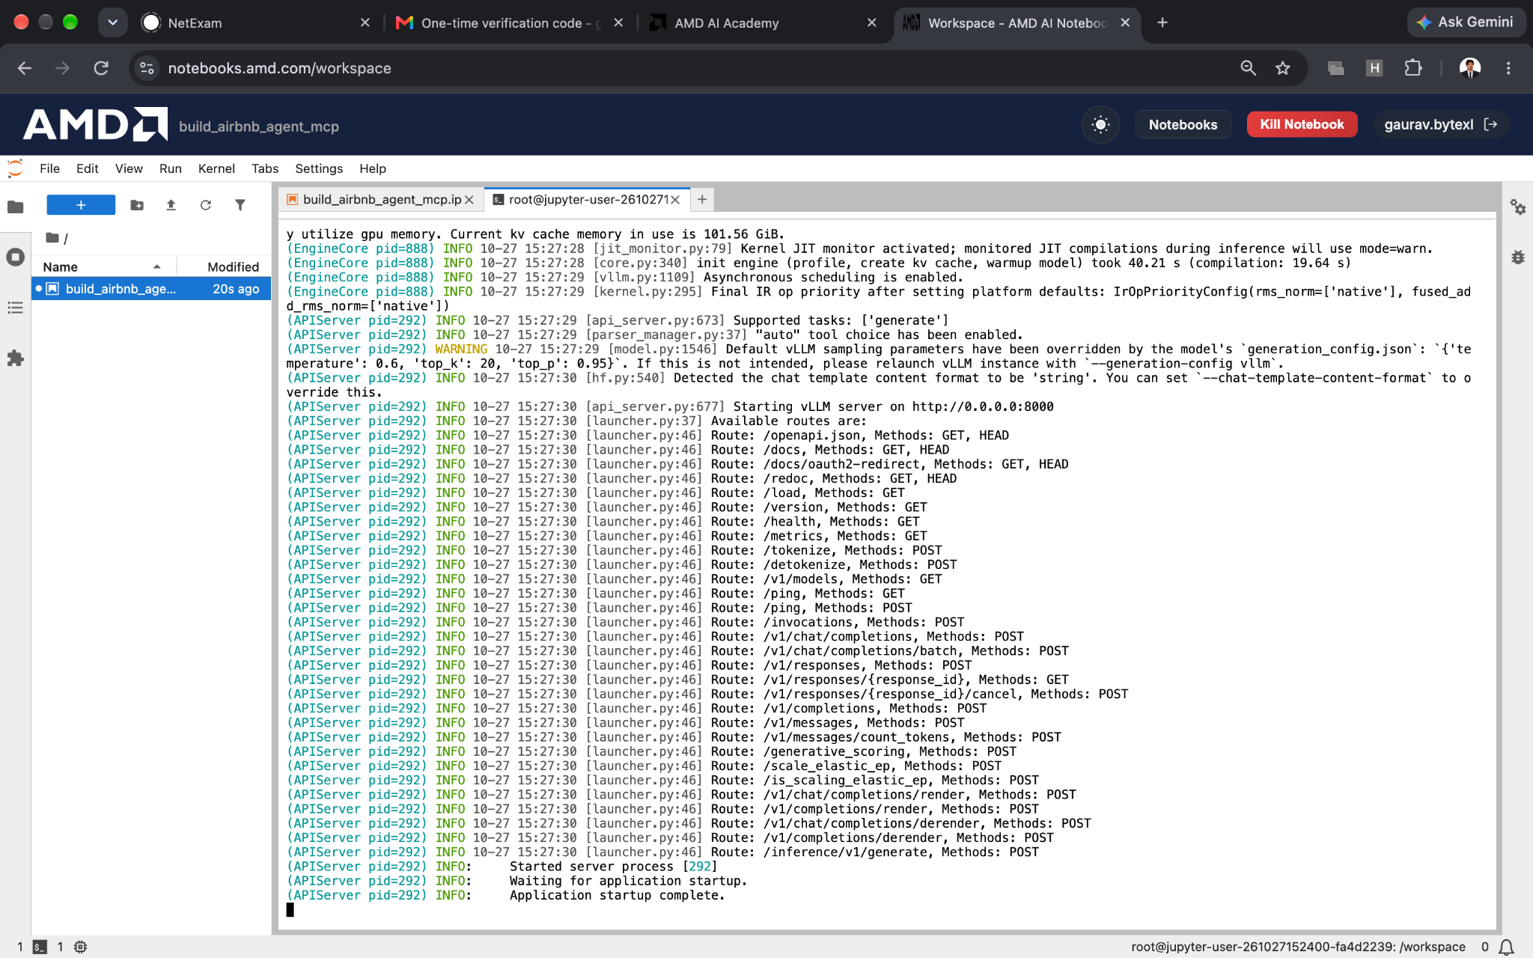

Step -2
At Last there is one option Click to add cell
Click on the add a cell

Add 3 cell and Write 3 codes one by one their in different cells
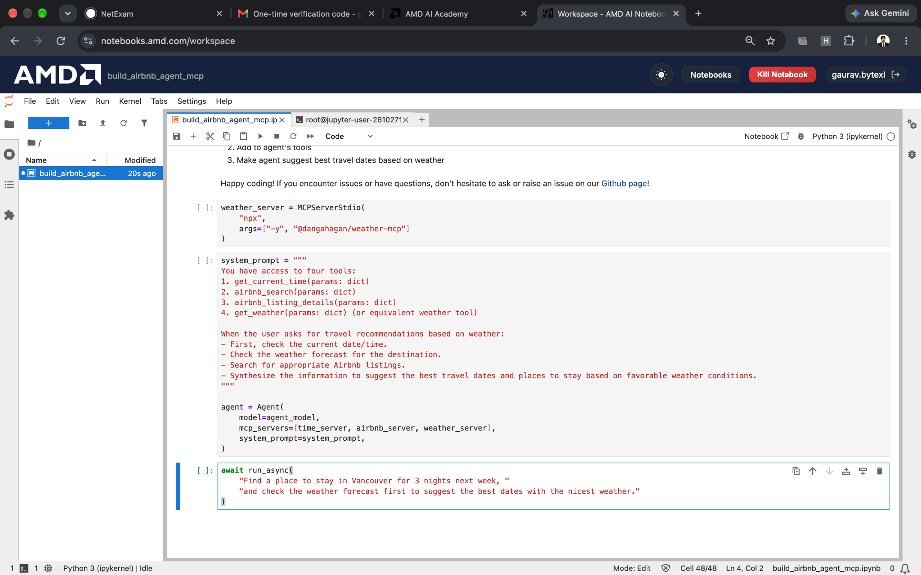
Just Run the cells by pressing it on the triangular shape button
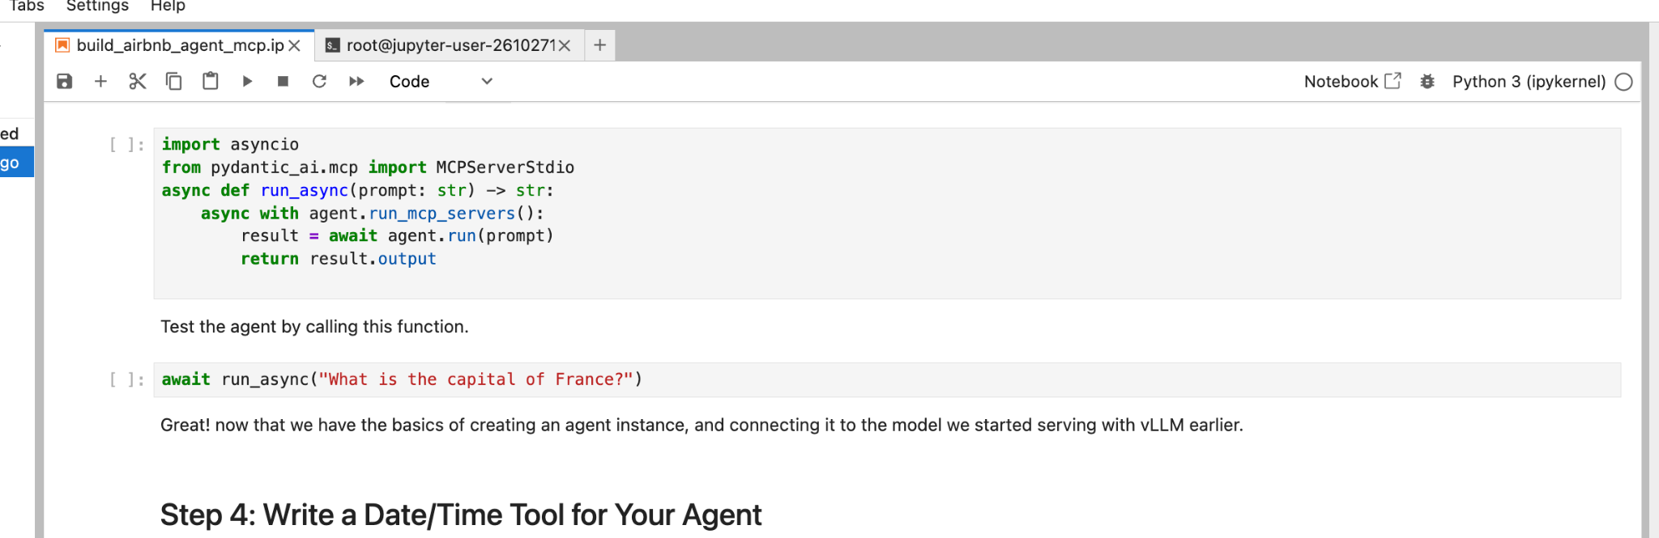
Run it till last and then
Click on file and then Save All and save Notebook

